Pupil Premium Funding 2015 -2016

Our strategic plan for allocating our Pupil Premium spend is based around our core beliefs that all our children should be educated in an inclusive environment where curriculum opportunities are broadened and high aspirations fostered.
This is our plan for the year 2015-2016. Outcomes will be updated and provision monitored termly as the year progresses.

Provision | Cost | Objectives | Outcomes
Free School Meals and Milk Provision | £21,000 | To ensure children receive a hot cooked meal that is nutritionally balanced daily.
Support Staff, including a Child and Family Liason Officer and Pastoral Support Worker. | 1/3 of annual salaries with on costs - £38,171 | - High quality support for learning within the classroom  - Engagement with children and families who require support, ensuring children are ‘emotionally ready’ to learn. | Jan 2016 – both positions in post.  10 families actively engaged and supported by Child and Family Liason Officer.
Inclusion Manager | 1/3 of annual salary with on costs - £14,530.60 | To ensure all pupils are accessing high quality education. | Jan 2016 – Vulnerable pupils receiving external agency support, intervention needs identified, high quality teaching supported.
Sistema Music Tuition | £8000 | To widen the opportunities for pupils to participate in learning a musical instrument and develop the social skills required to work as an orchestra. | Jan 2016 - 50 pupils receiving high quality music tuition.
Subsidised places at Breakfast Club | £5000 | To enable pupils to have a nutritious breakfast before the school day. | Jan 2016 – project being developed to enable this provision to reach a wider range of pupils.
Lead Practitioner for Teaching and Learning | £10,390.50 | To provide Continuous Professional Development through a team teaching approach enabling high quality teaching. | Jan 2016 – All year group teaching teams received coaching and team teaching approach, raising aspirations for all pupils.
Innovation Projects | £3000 | Continuous Professional development for staff to provide high quality inclusive education opportunities for all. | Jan 2016 – REAL projects training and support for all staff: see pupil voice within school for impact so far.
Enrichment Opportunities | £10,000 | Additional opportunities such as visits and visitors to broaden the curriculum and raise aspiration of all pupils. | Jan 2016 – School visits engaging all pupils, see in school pupil voice for outcomes so far.
Nurture Support through Unthank Family Centre | £5000 | Targeted support for pupils and their families to ensure they are ‘emotionally ready’ for learning. | Jan 2016 - 7 families supported at the moment with improved outcomes on pupil behaviours for learning.
Total Spend | £115,092.10

Last year’s Pupil Premium spend is detailed on our school website under ‘Pupil Premium 2013-2015’. The impact of that spend on results is illustrated below.
Good progress according to the Ofsted Inspection Framework December 2015 is deemed to be where –
The school’s actions secure improvement in disadvantaged pupils’ (those receiving the pupil premium grant) progress in English and Mathematics.
The progress of disadvantaged pupils is moving towards that of other pupils with the same starting points.
The progress of disadvantaged pupils is improving to be similar to that of national non disadvantaged (national other) pupils.

Pupil Premium Outcomes 2014-15
All data taken from Wensum Junior School 2015 Unvalidated Inspection Dashboard.
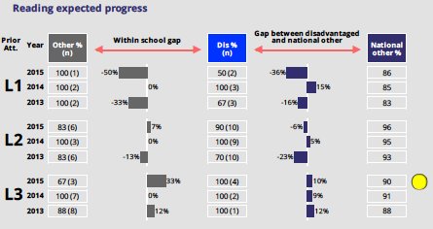
Pupil Premium progress is good because:
- The % of pupils starting our school at level 3 achieving expected progress is higher than national other pupils (10%).
- The gap between disadvantaged and national other pupils starting from age related level (level 2) has decreased from 23% to 6% over two years.
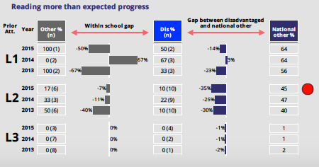
Pupil Premium progress:
- The gap between disadvantaged and national other pupils for those starting our school at level 1 has reduced from 23% to 14% over two years.
- However, the gap between disadvantaged and national other pupils who started our school at age related expectations (level 2) has increased slightly from 2013-2015.

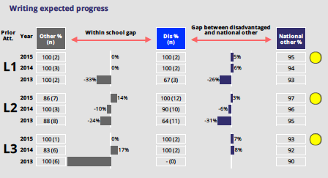

Pupil Premium progress is good because:
- The % of pupils achieving expected progress from all starting points is higher than national other pupils.
- The within school gap from all starting points has been eliminated over the last 3 years.

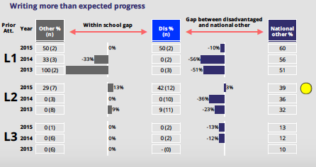

Pupil Premium progress is good because:
- The gap between disadvantaged and national other pupils from all starting points has been closing over the last 3 years.

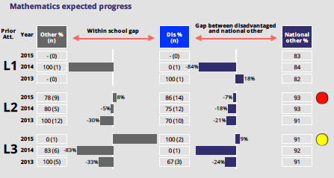

Pupil Premium progress is good because:
- The gap between disadvantaged and national other pupils for those starting our school at age related expectations (level 2) has decreased over the last 3 years.
- For those pupils starting our school at level 3, disadvantaged pupils outperformed national other pupils in 2015 (9%).

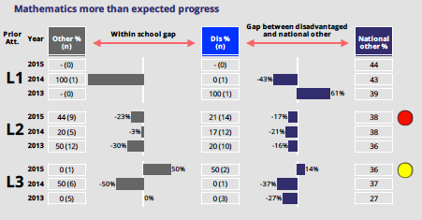

Pupil Premium progress is good because:
- Disadvantaged pupils starting our school at level 3 outperformed national other pupils in 2015 (14%).

